**TC1018 – Data Structures**

**Fall 2018**

**Final exam – 75 minutes**

Instructions: Answer the questions below. You can use one sheet of notes

Name: _____________________________________________________________

1. **[10 points]** Find the best answer to the following multiple choice questions
   1. Which of the following operations is not efficiently supported by a singly-linked list?
      1. accessing the element in the current position
      2. insertion after the current position
      3. insertion before the current position
      4. moving to the position immediately following the current position
      5. all of the above are efficiently supported
   2. The runtime of an algorithm depends on
      1. Data size
      2. Processor speed
      3. Language
      4. RAM
      5. All of the above
      6. None of the above
   3. Insertion of a node into a doubly linked list requires how many changes to various Next and Prev pointers?
      1. no changes
      2. 1 Next, 1 Prev
      3. 2 Next, 2 Prev
      4. 3 Next, 3 Prev
      5. none of the above
   4. What is the best data structure to solve the following problem? A list needs to be built dynamically. Data must be easy to find, preferably in O(1). The user does not care about any order statistics such as finding max or min or median.
      1. Use an Array
      2. Use a Singly LL
      3. Use a Stack
      4. Use a Queue
      5. None of the above
   5. The header node of a linked list
      1. simplies deletion
      2. simplies insertion
      3. uses only constant extra space
      4. two of the above
      5. all three of (a), (b), and (c)
   6. Which of the following is not a stable sorting algorithm in its typical implementation.
      1. Insertion sort
      2. Merge sort
      3. Quick sort
      4. Buble sort
   7. What type of graph is used in Twitter?
      1. Directed graph
      2. Undirected graph
      3. Partially connected graph
      4. Tree
2. **[10 points]** A police department wants to maintain a database of up to 1800 license-plate numbers of people who receive frequent tickets so that it can be determined very quickly whether or not a given license plate is in the database. Speed of response is very important; efficient use of memory is also important, but not as important as speed of response. Which of the following data structures would be most appropriate for this task?
   1. a sorted linked list
   2. a sorted array with 1800 entries
   3. a hash table using open addressing with 1800 entries
   4. a hash table using open addressing with 3600 entries
   5. a hash table using open addressing with 10000 entries
3. **[10 points]** Complete the following method in the LinkedList class. The method contains is supposed to return true if the there is a node in the list that is equal to the given Comparable c. You can assume the Node class has the public fields, data (a Comparable) and next (a pointer to another Node).   
   1. public boolean contains(Comparable c) {

1. **[10 pts]** Using a regular queue implement a Stack

1. **[10 pts]** Write an iterative Reverse() function that reverses a list by rearranging all the .next pointers and the head pointer. Ideally, Reverse() should only need to make one pass of the list.

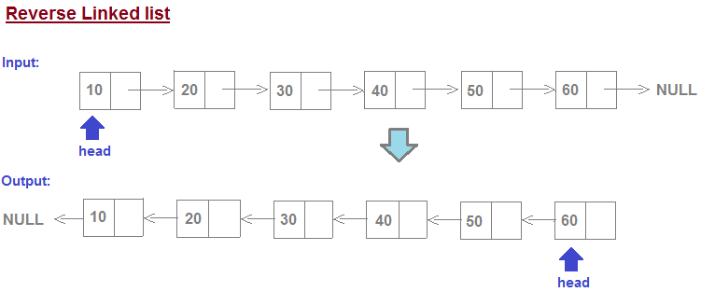

1. **[10 pts]** The adjacency list representation of a graph with five vertices A, B, C, D, E is given below

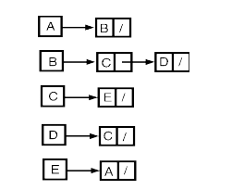

* 1. Draw the adjacency matrix

1. Draw the graph
2. **[10 pts]** Consider a singly linked list of nodes and the following method is called on the head node of the list:

void mystery(Node node) {

if(node == null) return;

mystery(node.getNext());

System.out.println(node.getData());

}   
  
The given linked list is shown below. What will the above program print?



1. **[10 pts]** Suppose you were asked to write a method that will take two sorted stacks A and B (min on top) and create one stack that is sorted (min on top). You are allowed to use only the stack operations such as pop, push, size and top. No other data structure such as arrays are not allowed. You are allowed to use as many stacks as needed (HINT: 3 are enough). Note that elements on the stack can be compared using compareTo.
2. **[10 pts]** Write a Java method named copy() that takes a reference to the root node of a binary tree and creates a new tree (with its own nodes) that is the copy of the original tree. Hint: This method is much easier to write if you use recursion.
3. 1

/ \ / \

2 3 2 3

/ \ / \

4 5 4 5

/ \ / \

6 7 6 7

public static Node mirror(Node root) {